Earth Shard

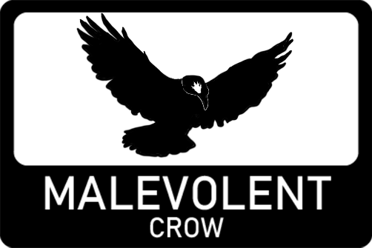

Game Design Document

Version 1.0

Contents

2 Overview 4

2.1 Concept 4

2.1.1 Gameplay loop 4

2.1.2 Main Objective 4

2.2 Look and feel 4

2.3 Scope 5

2.3.1 Locations 5

2.3.2 Levels 5

2.3.3 Player abilities 5

2.3.4 Enemies 5

3 Design 5

3.1 Narrative 5

3.2 Environment 5

3.3 Characters 5

3.3.1 Player 5

3.3.2 Rock Golems 6

3.4 User Interface 6

3.4.1 Menus 7

3.4.2 HUD 8

3.5 Camera Positioning 8

3.6 Sound Effects 8

3.7 Music 9

3.8 Lighting 9

4 Levels 9

4.1 Level 1 – Dunes 9

4.1.1 Synopsis 9

4.1.2 Objective 9

4.1.3 Map 10

4.2 Level 2 – Labyrinth 10

4.2.1 Synopsis 10

4.2.2 Objective 10

4.2.3 Map 11

4.3 Level 3 – The climb 11

4.3.1 Synopsis 11

4.3.2 Objective 11

4.3.3 Map 11

4.4 Level 4 – Rite of passage 12

4.4.1 Synopsis 12

4.4.2 Objective 12

4.4.3 Map 12

5 Mechanics 12

5.1 Controls 12

5.1.1 Keyboard and Mouse 12

5.1.2 Gamepad 12

5.2 Collisions and physics 12

5.3 Player Mechanics 13

5.3.1 Movement 13

5.3.2 Abilities 13

5.3.3 Player Health 13

5.3.4 Arm animations 14

5.3.5 Interactions 14

5.4 Enemies (rock golems) 14

5.4.1 AI (state machine) 14

5.4.2 Enemy Health 15

5.5 Interactable entities 15

5.5.1 Switches 15

5.5.2 Signs 15

5.5.3 Buttons 15

5.6 Timer mechanic 15

5.7 Saving and loading 15

6 Appendices 16

6.1 Concept art 16

6.1.1 Ability concepts 16

6.2 Mood boards 16

6.2.1 Environment 16

6.2.2 Rock Golems 17

6.3 Unused content 17

6.3.1 Minotaur (rejected idea) 17

6.4 Easter eggs 18

6.4.1 Ea-nāṣir 18

6.4.2 Rudy 18

# Overview

## Concept

You are an Earth elementalists and must face 4 trials to prove yourself to the master of Earth manipulation! You must use your abilities wisely to solve puzzles and defeat foes! Only then will you be able to become a master!

Earth Shard is a First-person shooter / puzzle game where you take the role of an initiate who is has discovered that they wield the power of earth manipulation and must face a series of trials to prove you have the wits and power to become a master of the element earth.

### Gameplay loop

The gameplay loop shifts slightly between the levels, but the main focus is on puzzle solving and combat.

#### Combat

The combat loop involves dodging enemy projectiles and shooting your own projectiles back to take them down. Earth shard uses Unity’s physics systems here and you must consider the angle in which you shoot your projectiles as they are affected by gravity.

#### Puzzle solving

On level 2 onwards puzzles solving takes a larger focus with Level 1 having you wander a maze shooting at switches to open a door at the end of it and level 3 using the ground raise ability to platform out of a pit. Level 4 combines some of the puzzle aspects of 2 and 3 with the combat of level 1.

### Main Objective

The main objective of Earth Shard is to make it to the end of each level and eventually become a master of the earth element by defeating all 4 trials.

## Look and feel

Earth Shard has an arid rocky feel to its environment to really embody the element of earth. The art style takes on a low poly aesthetic, this is both just an aesthetic choice and a practical choice as low poly assets are easy to blend and make if necessary.

## Scope

### Locations

The main overall location is a very arid desert mesa. There is a temple you enter in level 2 that will then exit to canyon that you escape from that opens into a rockier mesa much like the first location in Level 1.

### Levels

There are 4 levels each focusing on a different aspect of earth shard with the last level aiming to combine them all. The levels aim to scale in complexity as the earth shard progresses to keep the player engaged. With the final level aiming to really challenge the skills the player has learned from the other 3 levels.

### Player abilities

The player has 2 abilities they can utilise, one is a combat focused ability they can use to attack enemies or interact with switches. The second ability allows the player to raise themselves up which is useful for platforming or getting height advantage on enemies.

### Enemies

The enemies are rock golems to embody that earth element. The enemies use a state machine to control their AI with 3 different states: patrol, search and attack. The enemies when attacking will throw rocks at the player.

# Design

## Narrative

You (the player) are a sorcerer who has the ability to manipulate the element of earth! But in order to prove yourself worthy of wielding such a power you must find your way to the temple of the masters! But it is a treacherous journey that must have you face the 4 trials. The dunes, the labyrinth, the climb and the rite of passage. If you are able to defeat all 4 challenges set before you, the master will take you on as an apprentice and teach you the ways of earth manipulation!

## Environment

## Characters

### Player

The players character itself doesn’t have a design as it is never seen from a 3rd person perspective. The player is represented through two arms that animate with abilities.

The player also has no voice lines. This is following the trope set in older first-person games such as halo and half-life where the player character can be a self-insert of the person playing the game.

A design may later be considered for the player if any art requires them to be represented but as of now the player is just some arms. 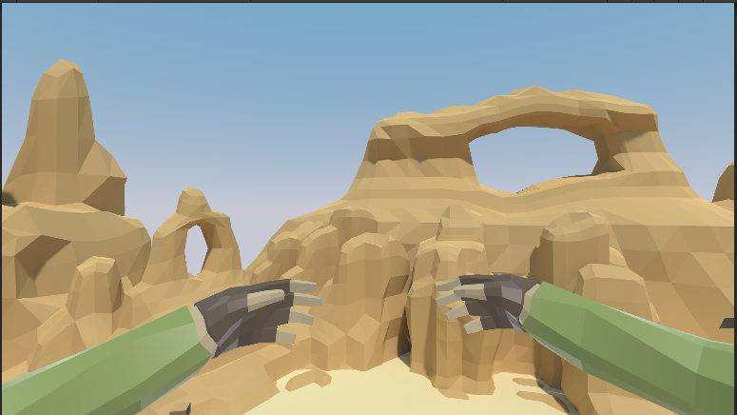

### Rock Golems

## User Interface

The UI of earth shard has rocky appearance with buttons looking like stones (WIP). The HUD is rather minimalistic as to not obstruct the gameplay and provide more immersion.

### Menus

#### Main Menu

The main menu will be the first screen you load into, it will consist of 3 options:

* Play: which will load you into the Level Select screen.
* Credits: which will load you into the Earth Shards credits menu.
* Quit: which will exit the game.

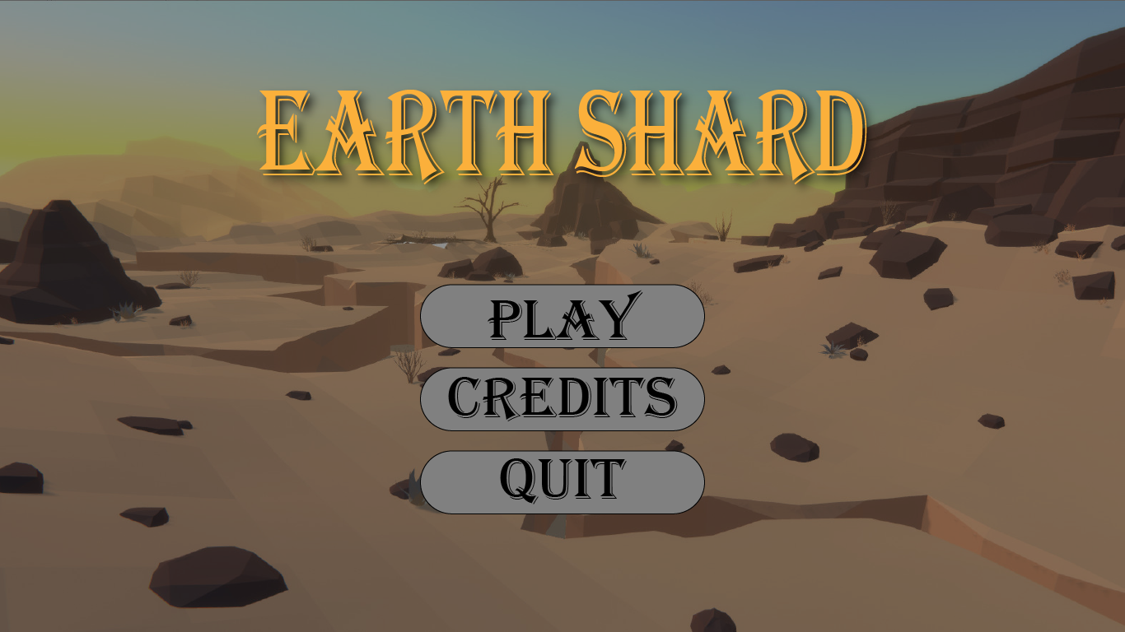

#### Level Select

The level select screen allows you to select any level you have completed previously. As well as having an option to return to the main menu.

#### Credits

Credits screen will show all contributors too the project. This is an ever going and changing list as of now.

#### Pause Menu

Pause menu can only accessed while in gameplay. This menu will pop up and pause all gameplay and give the play the ability to either quit or return to main menu.

#### Level end screen

Upon completing a level, the player will be given the option to continue to next level or return to menu. This screen will also display how fast the player completed the level for replay ability.

#### Death screen

The death screen will tell the player they have died and allow them to restart the level or return too main menu.

### HUD

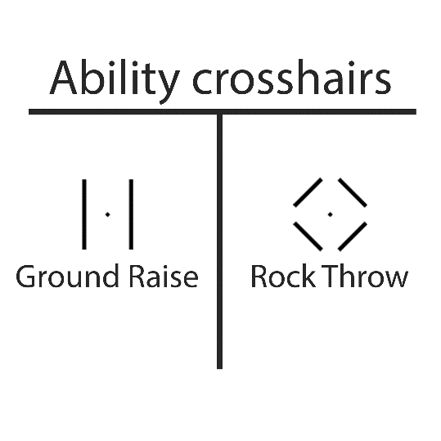The HUD is only shown as the crosshair that changes shape based on what ability is equipped at the time. When the player takes damage, a red glow will appear and when the players health is low the red glow will remain on screen before disappearing after some passive healing. There is no displayed health bar as it felt obstructive.

## Camera Positioning

Being a first-person game, the camera will always be position from the perspective of the player. In the menus the camera will show environments in the background with the menu overlayed.

## Sound Effects

Most interactions in the game have sound effects. Any collision or interaction will have a sound to give feedback to the player. The player movement itself also has sound effects.

Ambient sounds of the environment will add to the immersion with the sound of wind blowing in the open desert sections cave like sounds within the temple area.

The enemies will also have some ambient sounds to alert the player of their location.

## Music

Music is sourced from 3rd party assets and will play through each level and in the menu. There are considerations to make some music for the game but that must wait till towards the end of development if time permits it.

## Lighting

Earth Shard uses Unity’s built in universal render pipeline. Using lights from suns directional light too any light entities can be baked for smoother light maps which give the Earth Shard a higher quality look. Most of these lights will be using a mix of baked and real time rendering that allows for environmental light reflections to be baked in while dynamic objects like the enemies and projectiles will still cast dynamic shadows.

# Levels

## Level 1 – Dunes

### Synopsis

Level 1 is rather open and only involves killing enemies to progress, keeping it simple will allow players to learn the controls and one of the main abilities before moving into more complex mechanics.

### Objective

Kill enemies in two sections; after killing all enemies in each section a door will open with the last door opening to the entrance of a temple leading to the next level.

### Map

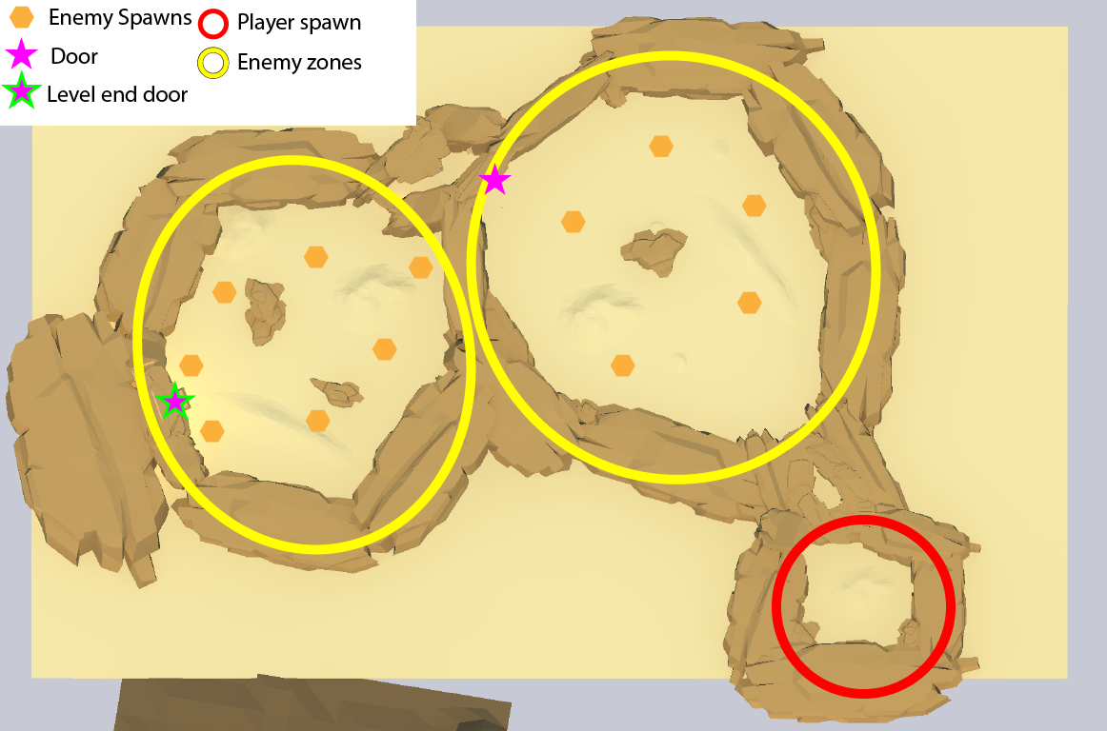

## Level 2 – Labyrinth

### Synopsis

Level 2 is more puzzle focused, the player is introduced to the switches which are found throughout the labyrinth and the player must then use the switches to open a door at the end of the labyrinth.

### Objective

The main objective of this level is to activate 3 switches hidden throughout the level. Once all 3 switches are activated the door at the end of the level will open and allow the player to progress to level 3.

### Map

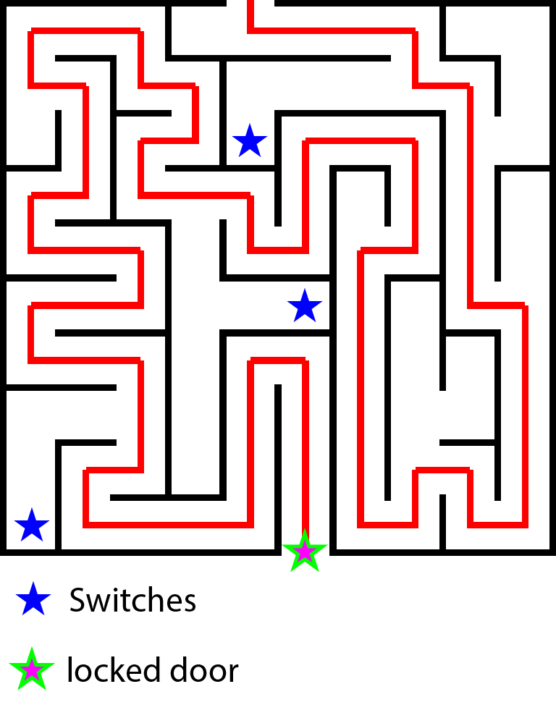

## Level 3 – The climb

### Synopsis

Level 3 is about platforming. In this level the player will have to climb out a canyon using the platform raise ability. This player introduced the player to the player to this new ability and by platforming with it through this level will give the player the time to learn how it works.

### Objective

The objective of this level is to climb out of the canyon and make it to the end of the level before progressing onto the final challenge.

### Map

//insert map

## Level 4 – Rite of passage

### Synopsis

This level is where the player will use all the skills they have learned. This level will have bits of platforming mixed with enemies and hidden switches. This level should be difficult as it is the final level of the game.

### Objective

Make it to the end of the level while fighting enemies, platforming and searching for switches.

### Map

//insert map

# Mechanics

## Controls

Earth Shard was built mainly on keyboard and mouse but also has controller support due to the ease of Unity’s new Input system.

### Keyboard and Mouse

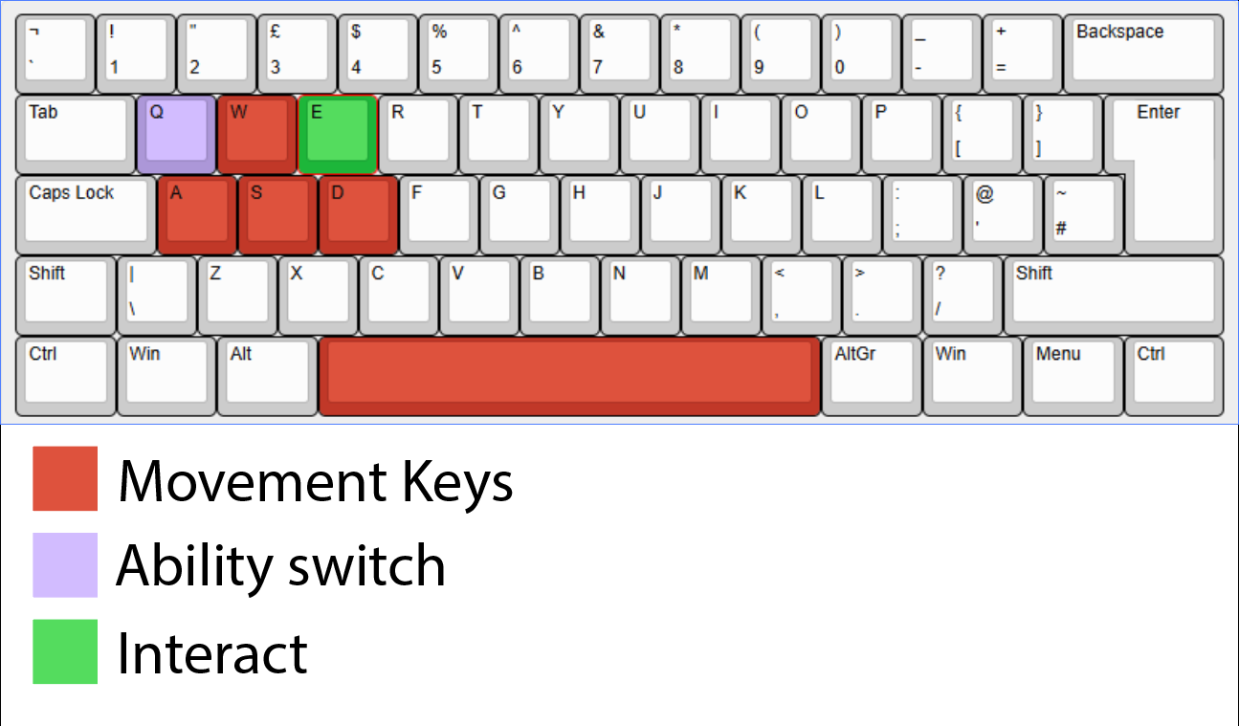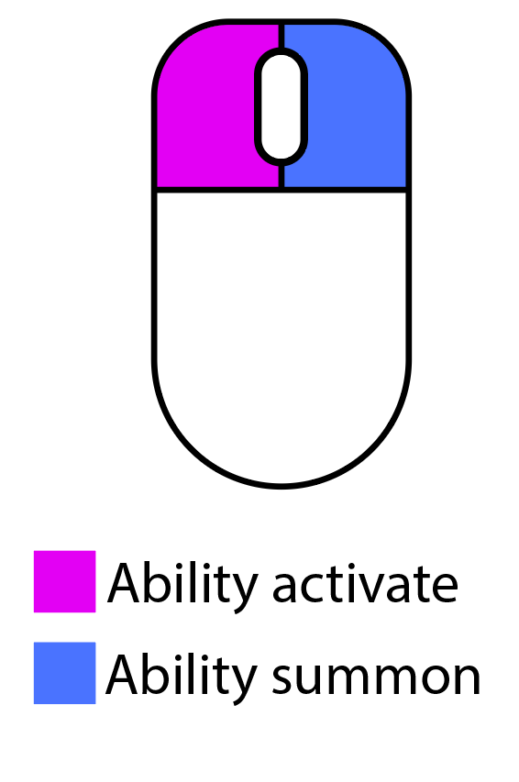

### Gamepad

//insert gamepad mock up

## Collisions and physics

Earth Shard uses Unity’s built in physics and collision system. Standalone colliders are only for static objects that make up the environment. For dynamic Objects like the Player, Enemies and projectiles will use rigid body components for better calculations and physics simulation.

## Player Mechanics

### Movement

The movement in Earth Shard is modelled after what is used in nearly all games in the FPS genre with lateral movement and jumping affected by gravity.

### Abilities

Earth Shard has 2 abilities each serving a different purpose with rock throw as a more combat focused ability and ground raise as a more puzzle solving related ability.

The abilities in earth shard can be switched between each other once reaching level 3, using the ability switch key. The player will start with the rock throw ability at first. The selected ability is shown by the crosshair symbol present.

#### Rock throw

The rock throw ability is the first ability the player can use. The player can with summon the rock with the ability summon click and fire the rock with the ability activate click.

When the rock is summoned, it is held in front of the player and has no collisions until it is fire in which it will have force applied in whatever direction it is facing, it will also be affected by gravity as it will have its rigid body activated upon being fired.

The destroys itself on collisions with a particle effect and can interact with enemy health and switches.

//gif of rock firing

#### Ground raise

The ground raise is the second ability the player unlocks at level 3. The ground raise ability works by spawning a rock under the player with ability summon click and is raised up ability activate click. The platform that raises the player will raise to maximum of 5 metres and will slow its speed of ascension as the player reaches the max height.

The platform will always spawn in the same direction as the player and when summon ability is used again the platform will be destroyed and will need to be summoned again. When destroyed the platform create a particle effect and play a sound.

The player does not need to be standing on the platform to raise it.

//gif of platform raising

### Player Health

The player health is scaled with 100 hit points, but this is not displayed to the player. The player will see a red glow around the edges of the screen when taking damage. When the health is below a threshold of 25 the glow will stay on the screen.

The player passively heals over time when out of combat.

### Arm animations

The players arms animate when abilities are summoned or activated and play different animations depending on the ability equipped.

The rock throw animation will show the arms moving up as a rock is summoned and the arms pushed forward when thrown.

The ground raise animation has the player move hands upwards when the ability is activated.

### Interactions

Interactable objects will have text display on screen showing its interactable and pressing the interact key will cause a function to trigger. The function can be programmed depending on the object.

## Enemies (rock golems)

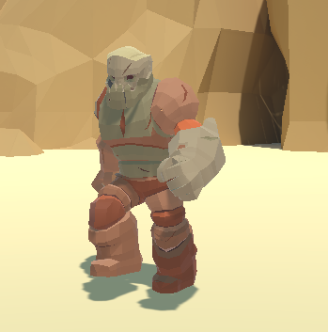Rock Golems are the only enemy the player will encounter. They are rather slow; this is mostly due to limitations with my knowledge on AI an animation within unity. They use a basic state machine to control their behaviour.

Rock golems use a blend tree to handle animations, but due to lack of knowledge on how blend trees work in unity they enemies tend to be a bit glitchy with animations but still function smoothly.

### AI (state machine)

There are 3 states the enemy will move between; the enemies always start in a patrol state.

#### Patrol State

The patrol state is the default state of enemies. In this state the enemies will follow path that is set with waypoints, if set to loop the enemy will go through each checkpoint until complete then going back to the first one. In this state the enemy will scan in front of them until they see a player. In which case they will enter the attack state.

#### Attack State

The attack state is when the enemy will fire projectiles at the player. In this state the enemy will always path a certain distance towards the player. And randomly move around a set position to make it harder for the player to hit them. If the player goes out of range the enemy will enter the search state.

#### Search State

In the search state the enemy will path towards the players last scene position. If the enemy sees the player, it will enter the attack state once again, if not the enemy will search a radius around the players last know position for a time before returning to the patrol state.

### Enemy Health

Enemy health is simple 50 hit points. Upon hitting 0 hit points the enemy will die with a particle effect.

## Interactable entities

### Switches

Switches are interactable entities that can only be activated with a rock thrown by the player. When activated switches will change colour to indicate they are active. Switches can be programmed to activate any number of components are a modular component.

### Signs

Signs can be interacted with by the player to display text. These will be used to guide the player on how to use mechanics or give information about the games story.

### Buttons

Current version of the game has no buttons as they are used as a testing feature only to activate events quickly while running a build of the game. Buttons display their function on the HUD and will activate whatever they are programmed with when interacted with.

## Timer mechanic

Each level in Earth Shard will be timed allow the player to go back and try beat previous times on levels. Each time high score is saved for each level.

## Saving and loading

Earth shard will save progress by saving what level you have played up too along with the score on each level.

# Appendices

## Concept art

### Ability concepts

The original concept art for how the abilities would function in Earth Shard.

## Mood boards

### Environment

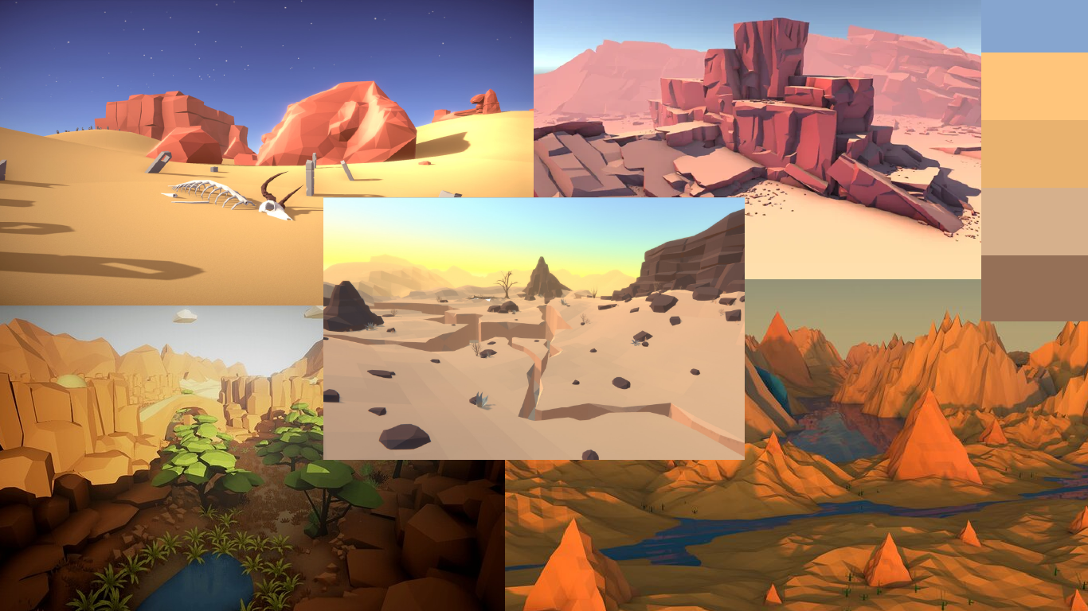

### Rock Golems

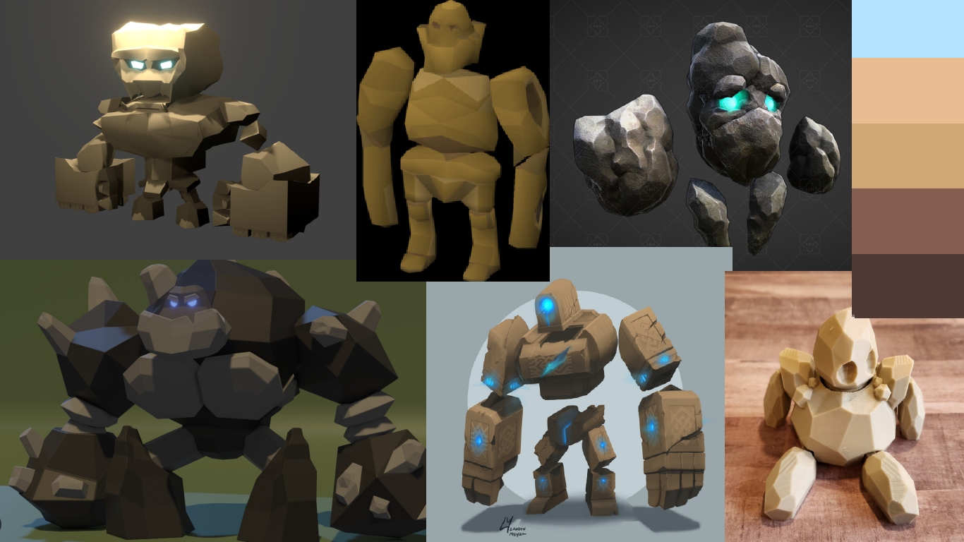

## Unused content

### Minotaur (rejected idea)

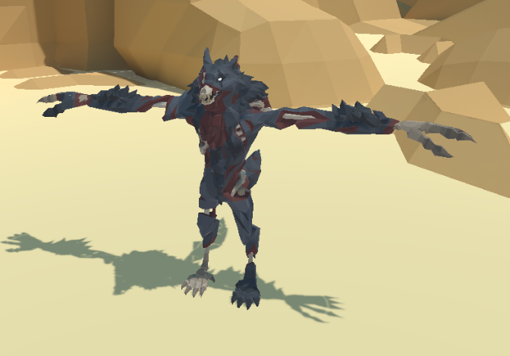The minotaur was supposed to be an invincible enemy that would stalks the labyrinth of level 2 and chase the player when they were in range of it. A minotaur model that matched the low poly art style could not be sourced so an undead werewolf was used instead. But due to complications with animations and AI the idea was scrapped as it would take up far too much time.

See Level 2 – the labyrinth.

## Easter eggs

### Ea-nāṣir

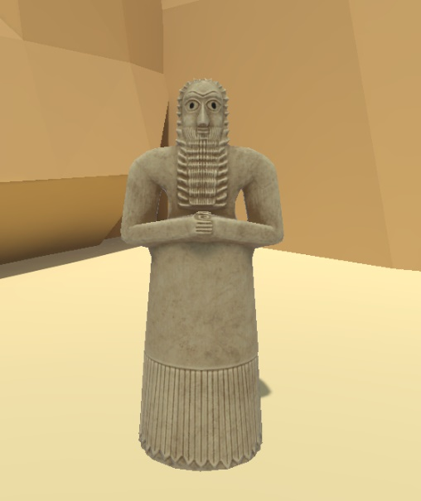Ea-nāṣir (𒂍𒀀𒈾𒍢𒅕) was a copper merchant that lived in the ancient city of Ur, which was in the modern-day Governorate Dhi Qar, which is in southern Iraq. He lived in the mid-18th century BCE and was known for selling poor quality copper to a customer named Nanni. Nanni did not like the quality of copper sold to him by Ea-nāṣir and wrote a complaint on a clay tablet. The tablet was rediscovered by Sir Leonard Woolley and was transported to the British museum where it resides today.

This tablet now the last remaining remnant of Ea-nāṣir’s legacy.

[See more.](https://en.wikipedia.org/wiki/Ea-n%C4%81%E1%B9%A3ir)

Ea-nāṣir can now be found in Earth Shard as a statue of a Sumerian worshipper and play a Sumerian prayer when approached in game.

### Rudy